M4-DB Narrative
Artifact Description
The artifact selected for this enhancement is my CS 340 Animal Shelter Dashboard, originally developed in CS 340: Client/Server Development. The application uses a Dash interface connected to MongoDB to display, search, filter, and manage animal shelter records. The Milestone Four work builds on the modular architecture completed for Milestone Two and the searching, filtering, sorting, caching, and data-processing improvements completed for Milestone Three. For this enhancement, I strengthened the database layer by adding MongoDB JSON Schema validation, database indexes, full CRUD operations, server-side aggregation, query validation, and improved exception handling while maintaining the existing application functionality.
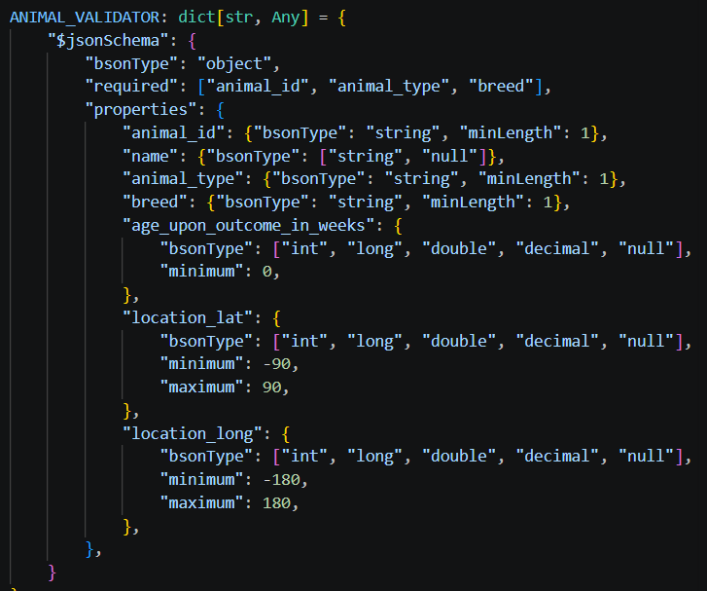
MongoDB JSON Schema validation enforcing required fields and valid data types. File: grazioso/repository.py, lines 46-80.

Inclusion Justification
I selected this artifact because it demonstrates several database concepts used in professional applications and clearly shows my growth from the original CS 340 project. The original application performed basic MongoDB operations, but the enhanced version provides stronger controls for data integrity, performance, reliability, and security. The MongoDB validator requires core fields and limits numeric values such as age, latitude, and longitude. The indexes support common dashboard queries and prevent duplicate animal identifiers. The CRUD methods validate records, handle duplicate keys, and provide clearer error handling. These improvements make the application more reliable, scalable, and easier to maintain.
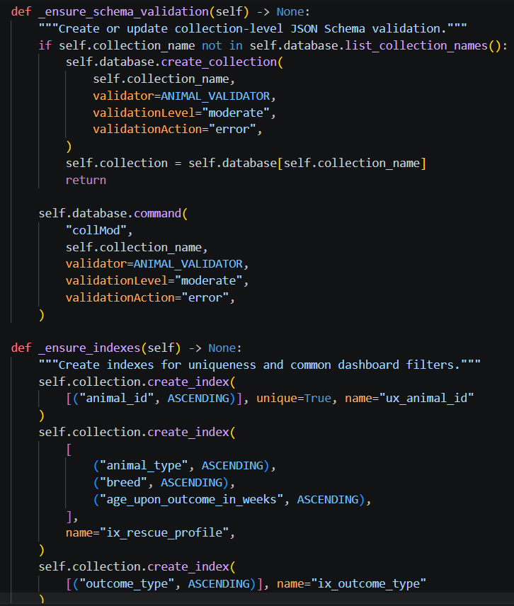

DB Enhancement
The DB enhancement focused on improving the existing MongoDB implementation instead of replacing the application's architecture. I added a startup process that verifies the MongoDB connection, applies JSON Schema validation, and creates a unique animal ID index, a compound rescue-profile index, and an outcome-type index. I also expanded the MongoDB repository to support create, read, update, and delete operations with application-level validation, duplicate detection, logging, and centralized exception handling.
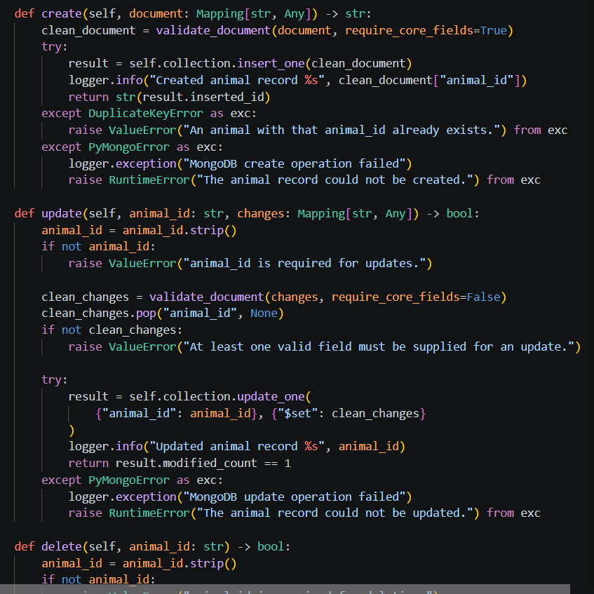

To improve processing efficiency, I implemented a MongoDB aggregation pipeline that calculates breed totals inside the database. The pipeline applies an optional match stage, groups records by breed, sorts the totals, and returns only the fields needed by the application. Performing this work in MongoDB reduces unnecessary data transfer and keeps the database responsible for data-intensive processing.
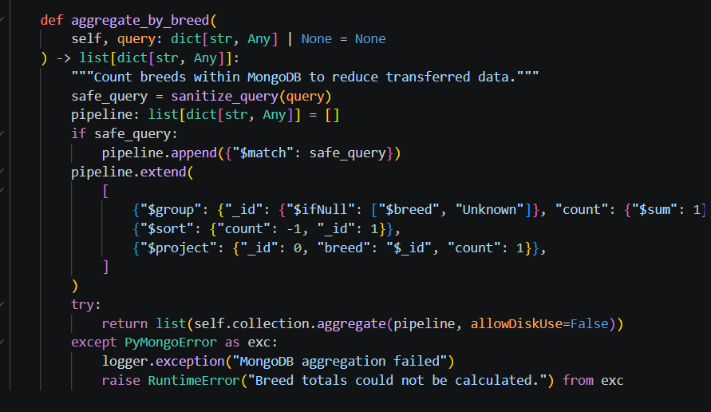
Security was improved through approved field and operator lists. Before a query is sent to MongoDB, the sanitization function checks that each field and operator is supported. Unsupported values raise an error rather than being executed. The project also continues to use environment-based configuration instead of hard-coded database credentials.
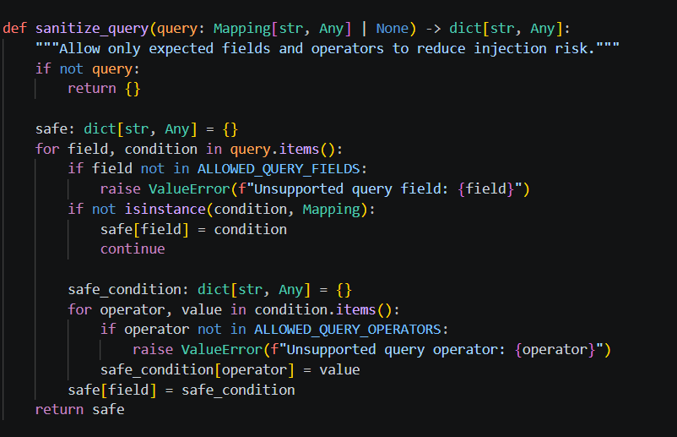
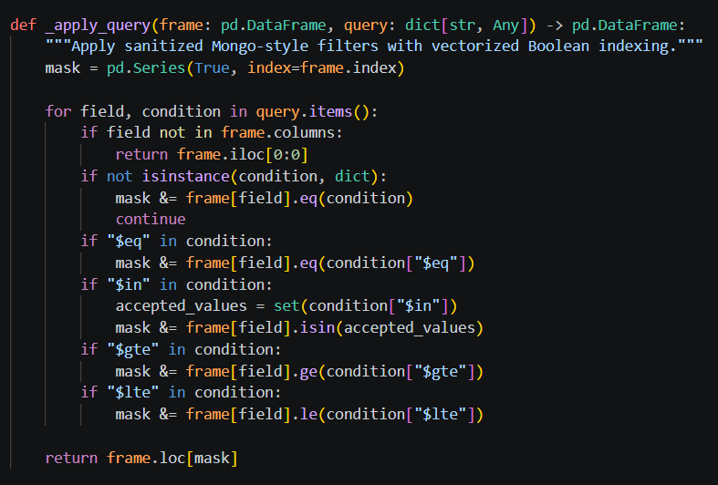

Course Outcomes
This enhancement primarily demonstrates Course Outcome Four by applying modern database techniques and tools to improve an existing computing solution. It also supports Outcome Three through indexing, query optimization, and server-side aggregation. Outcome Five is demonstrated through schema validation, input validation, approved query controls, environment-based configuration, and centralized exception handling. The completed work meets the database goals outlined in Module One, so I do not need to change my planned outcome coverage.

Reflection
This enhancement showed me that database development involves much more than basic CRUD operations. I gained a better understanding of how schema validation, indexing, aggregation, query controls, and application-level validation work together to protect data and improve performance. One challenge was adding the database improvements without removing the software design and algorithm enhancements completed in the earlier milestones. Working from the Milestone Three project allowed me to preserve the cumulative changes and add the database features to the same codebase. I also learned that database initialization must account for connection failures, existing collections, duplicate records, and invalid input instead of assuming every operation will succeed. Overall, this project strengthened my database development skills and better prepared me to design secure, scalable, and maintainable applications.

